**Day3 - Assignment 1:**

Create an infographic illustrating the Test-Driven Development (TDD) process. Highlight steps like writing tests before code, benefits such as bug reduction, and how it fosters software reliability.

**Test-Driven Development (TDD) Process**

Step 1: Write Test Cases

Define test cases based on expected behavior.

Tests are written before any code implementation.

Step 2: Run Tests

Execute tests to ensure they fail initially (Red phase).

Validates that tests accurately detect expected failures.

Step 3: Write Code

Develop code to pass failing tests.

Implement the minimum code necessary to satisfy test conditions.

Step 4: Run Tests Again

Execute tests to verify code changes (Green phase).

Tests should pass with the new code implementation.

Step 5: Refactor Code

Improve code structure without changing functionality.

Ensure code remains clean and maintainable.

Step 6: Repeat

Iterate through steps for each new feature or modification.

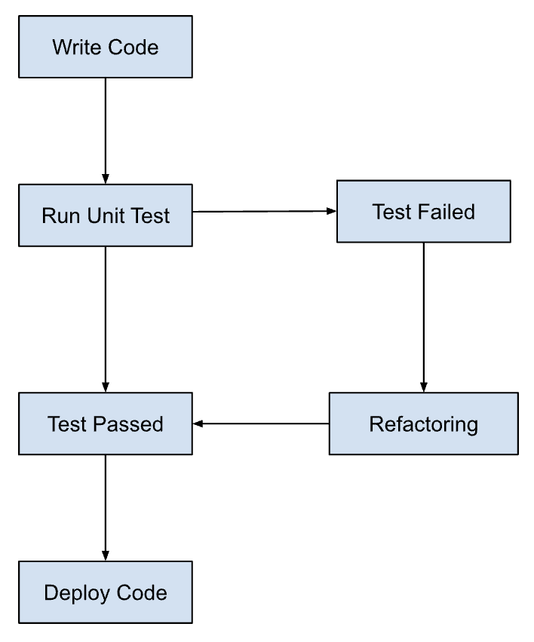

**Benefits of TDD**

Early Bug Detection

* + Detect and fix issues at an early stage.
  + Reduces debugging time in later development phases.

Improved Code Quality

* + Encourages modular, maintainable code.
  + Reduces technical debt and enhances scalability.

Faster Development Cycles

* + Ensures rapid feedback loops.
  + Increases overall development speed and efficiency.

Higher Software Reliability

* + Builds confidence in software functionality.
  + Enhances stability through continuous testing.

**Impact on Software Reliability**

Consistent Testing

* + Ensures comprehensive test coverage.
  + Guarantees robustness and reliability of features.

Reduced Defects

* + Minimizes production defects and rework.
  + Enhances customer satisfaction and trust.

Supports Agile Practices

* + Aligns with Agile methodologies.
  + Facilitates incremental and iterative development.

**Conclusion:**

Test-Driven Development (TDD) promotes a structured approach to software development, fostering reliability, reducing bugs, and ensuring higher code quality.